RESPONSE TO REVIEWERS
*Line numbers refer to the clean manuscript

REVIEWER 1
Reviewer 1, Comment 1: This study led by Eid, Jaisil, Guo et al., demonstrate that long-term ketogenic diet (KD) preserves peripheral nerve structure and function and reshapes metabolic and transcriptional pathways in both nerve and muscle, providing strong preclinical evidence that KD can prevent MetS-induced peripheral neuropathy. The integration of metabolic, hepatic, muscular, neural, and transcriptomic endpoints is impressive, with implications for whole health in addition to neuropathy. This study has a comprehensive experimental design, including both prevention and intervention paradigms, which is uncommon and strengthens causal inference and allows comparison of additive vs independent effects.

Our response: Thank reviewer
Reviewer 1, Comment 2: From my understanding, a central interpretive gap is the absence of comparisons between intervention groups (KDI, EXI, KDI-EXI) and the SDI diet-reversal group. As currently presented, all intervention effects are interpreted only relative to HFD? This leaves open the possibility that some improvements are driven by stopping HFD rather than by the interventions themselves. Analyses of KDI vs SDI, EXI vs SDI, and KDI-EXI vs SDI could help determine intervention-specific benefits. Authors could at least perform an analysis that removes DEGs shared between SDI vs HFD and each intervention vs HFD. This would isolate genes and pathways uniquely affected by KDI, EXI, or KDI-EXI rather than those reflecting generic reversal of HFD-induced injury.

Our response: Explain that we tried to be focused about which interventions we did to keep story clean
Maybe Junguk has these or can make these comparisons publicly available in repository?

Reviewer is saying that improvements are simply driven by stopping HFD rather than by the interventions themselves, but this would not be true for the EX group who remain on HFD

At least do analysis in last sentence, compare interventions but take out genes that overlap so that we are only looking at unique genes for each intervention and comparing across interventions

EX animals never stop HFD – do pathway enrichment of unique DEGs (Venn diagram)
Reviewer 1, Comment 3: While the authors state that their transcriptomic profiling is exploratory, the differential expression analyses rely on unadjusted p-values, and PCA shows no clear group separation. Without FDR correction, many of the reported DEGs and enriched pathways may represent statistical noise rather than robust biological effects. Several physiological and transcriptional changes are described, but the relationships between diet, exercise, and neuropathy remain associative, and the conclusions and discussion should clearly reflect this.

Our response: Agree and add as a limitation

Reviewer 1, Comment 4: Pathways highlighted in the manuscript particularly immune signaling, extracellular matrix remodeling, and lipid metabolism can be highly cell-type specific. Because bulk RNA-seq averages signals across many cell populations, these findings cannot be confidently mapped to specific cells. The authors could strengthen their interpretation by using existing single-cell reference datasets (e.g. Eid et al., J Neurochem 2023) to perform bulk RNA-seq deconvolution, which would help identify which cell types drive the observed transcriptomic shifts. Recent methodological benchmarks, such as Xu et al. Briefings in Bioinformatics (2025), provide clear guidelines for selecting appropriate deconvolution tools. At minimum, the authors should discuss the limitations inherent to bulk transcriptomics and maintain conclusions at an appropriately associative level.

Our response: Did do cybersort but didn’t see anything really interesting, add a sentence and say data not shown (don’t add data), love your comment, felt the same way, trends, nothing significant made sense, elected to not include as supplemental, elected to state in a sentence with data not shown that we didn’t see anything, just didn’t work

In addition to molecular changes in the SCN and GASTROC transcriptome, we were also interested in cellular changes underlying diets and interventions. As bulk RNA-seq lacks cell-type specificity, we used the CIBERSORTx analytical tool to cluster and estimate cellular heterogeneity using cell type-specific marker gene expression in SCN (49) and GASTROC (50) samples. This approach identified 17 total cell clusters in the SCN and 15 total cell clusters in the GASTROC (Figure 8).
In the SCN, 31-38% of the cell transcriptomes were assigned to myelinating Schwann cells, regardless of diet or intervention (Figure 8A; Figure S16A; Table S28). We observed an increase in the percentage of endothelial (blood nerve barrier) and CD4 T helper cells with HFD compared to SD (Figure 8A; Figure S16A; Table S28 and S29). HFD also induced a trending increase in the levels of fibroblasts (fibro; p-value=0.1) and decrease in non-myelinating Schwann cells (nmSCs; p-value=0.074) compared to SD, although these changes did not reach statistical significance. A rise in endothelial cells was noted in long-term KD animals relative to SD (Figure 8A; Figure S16A; Table S28 and S29). When comparing long-term KD to HFD, CD4 T helper cells were more abundant in SCN from HFD animals, whereas nmSCs were less prevalent in HFD animals compared to KD (Figure 8A; Figure S16A; Table S28 and S29). Cell-type composition between HFD and intervention groups showed no significant differences. However, a trending increase in nmSCs in the DR group compared to the HFD group (p-value=0.053) was noted. Additionally, EX increased CD8 T cell (p-value=0.052) and decreased CD4 T cell levels (p-value=0.087) relative to the HFD group, although these changes did not reach statistical significance. When comparing interventions, the percentage of myeloid cell lineage cells was significantly higher while vascular smooth muscle cells and pericytes were lower in EX compared to KDI-EX animals (Figure 8A; Figure S16A; Table S28 and S29).
In the GASTROC, 35-39% of the cell transcriptomes were consistently attributed to myonuclei cells, irrespective of diet or intervention (Figure 8B; Figure S16B; Table S28). A HFD induced a decrease in the levels of dendritic cells and a trending increase in myoblasts (p-value=0.089). When comparing a KD to SD, we observed an increase in the percentage of muscle stem cells with KD (Figure 8B; Figure S16B; Table S28 and S29). KD also reduced monocytes versus HFD animals (Figure 8B; Figure S16B; Table S28 and S29). With interventions, we observed a significant increase in the percentage of dendritic and T cells and a decrease in monocytes with DR compared to HFD (Figure 8B; Figure S16B; Table S28 and S29). A similar decrease in monocytes was noted in KDI-EX animals relative to HFD. In the EX group, monocyte levels were also reduced, although this change did not achieve statistical significance (p-value=0.067; Figure 8B; Figure S16B; Table S28 and S29). The percentage of dendritic cells was also significantly higher in DR animals compared to the other interventions (Figure 8B; Figure 16B; Table S28 and S29). Finally, T cells were more abundant in GASTROC from DR animals than EX mice (Figure 8B; Figure 16B; Table S28 and S29). These results indicate that, in the GASTROC, changes in cell-type were predominantly observed in immune system components in response to diet or interventions.

Reviewer 1, Comment 5: Exercise benefits to nerve and muscle may depend on intensity, duration, and modality, none of which are controlled or quantified in mechanistic terms. This limits interpretation of EX-specific adaptations and should be discussed.

Our response: This is in Keto CNS, completely agree and published as suppl data, have re-written section to be more clear according to reviewer’s comments

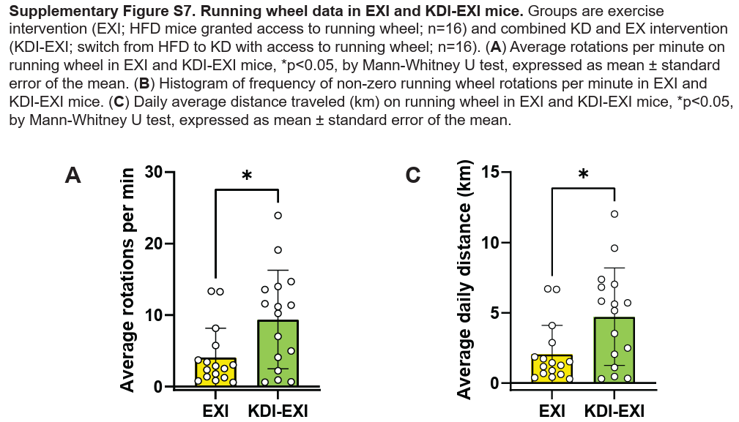
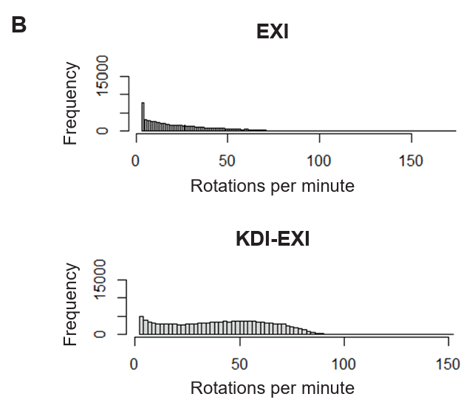
Reviewer 1, Comment 6: Given well-documented sex differences in metabolic regulation and neuropathy susceptibility, the exclusive use of male mice restricts the translational relevance of the findings and should be discussed.

Our response: We mention this in the limitations, but can highlight it more, completely agree, what a great suggestion, this is amzing

REVIEWER 2
Reviewer 2, Comment 1: This article provides detailed data in support of the preventative and therapeutic affects of ketogenic diet and exercise on peripheral Neuropathy in metabolic syndrome in mice.

Our response: Thank you
Reviewer 2, Comment 2: The extensive RNAseq data has not been confirmed at the protein level by WB or IF. Also some of the presumed metabolites by histological staining. It would be critical to define some lead targets for mechanistic studies at least in cell culture models.

Our response: We have protein lysate, need to do PCR, can also try Western blot, PCR on something different than the Western – have to check on what was left

Reviewer 2, Comment 3: The statement on the last sentence in page 12: "comparing KD versus HFD identified 451 DEGs, including reduced serpine -1,, a senescence marker with enrichment in senescence and p53 signaling pathways" is confusing. Is there an increase in senescence markers and SASP? If yes which specific markers are regulated? What are the effects of KD and exercise?

Our response: This is something that we noticed in this study and are now exploring further. No. – This is outside the scope of the study, just focus on comparison of interventions vs. HFD, panel is from EMBO paper

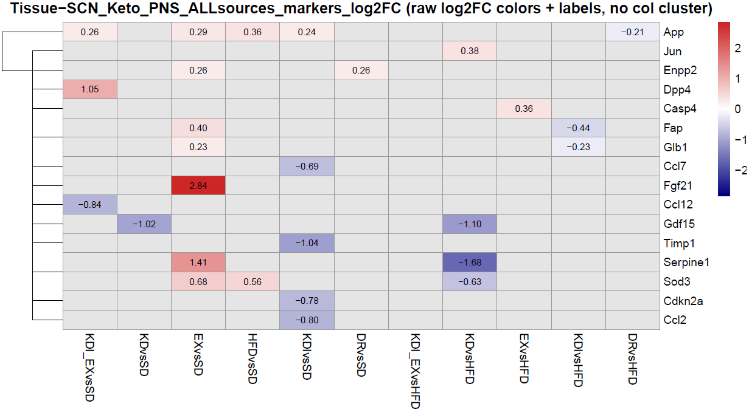
Reviewer 2, Comment 4: A mechanistic figure, such as the ones used in graphical abstract, summarizing the results and conclusions would be very helpful and enhance the article.

Our response: We can make a graphical abstract, not required, but encouraged

REVIEWER 3
Reviewer 3, Comment 1: In this manuscript, the authors test whether ketogenic diet, exercise, or both impact peripheral neuropathy in metabolic syndrome mice induced by high fat diet. The authors also begin to evaluate the mechanism for protection by bulk seq transcriptomic experiments from both peripheral nerve and muscle. Strengths of this manuscript include the clinical relevance of these translational experiments, the demonstration that combined therapy of both ketogenic diet and exercise is better than either alone, and the analysis of transcriptomic experiments. There are few weaknesses, but they are deemed minor and correctable. These weaknesses are detailed below.

Our response: Thank you

Reviewer 3, Comment 2: I don’t like the term “preventative” to describe the experiments comparing mice treated with normal, high fat, and ketogenic diets. What is the ketogenic diet preventing? The importance of these experiments is that the ketogenic diet does not induce the same toxicity as high fat diet, but the mice are not treated simultaneously with high fat and ketogenic diet, so preventative seems inappropriate. This should be modified throughout the manuscript and figures.

Our response: I get what they are saying, but not sure what other word we would use? Maintenance?

Reviewer 3, Comment 3: The neuromuscular junction quantification is different than most other publications. This one uses a histologic stain (acetylcholinesterase solution) and staining of nerve fibers with neurofilament. Most publications use a fluorescently labeled bungarotoxin to label muscle NMJ and presynaptic components labeled immunostaining synaptic vesicles in presynaptic terminals. This allows for quantification of fully innervated, partially innervated or denervated NMJs. Given the lack of significant changes in this manuscript, perhaps this is due to the technique. Authors should consider restaining and analyzing the muscle with this protocol. If not, they should add a figure showing a photomicrograph of their staining in supplemental figures and also justify the use of this method in the paper.

Our response: Add pictures. Justify – we’ve published three papers using this method. Ian can help with taking the pictures

Reviewer 3, Comment 4: The PCA analysis did not demonstrate defined separate groups. The importance or explanation of this should be discussed further in the paper.

Our response: And a sentence into the results. Agree, good point

Reviewer 3, Comment 5: The discussion of NMJ innervation results is misleading. State that “EXI uniquely increased NMJ innervation, improving neuromuscular connectivity.” Though technically true, it is hard to know how to interpret the importance of this result given that HFD did not induce a change in NMJ innervation.

Our response: Soften the language

Reviewer 3, Comment 6: All of the transcriptomics was completed in nerve or muscles at the end of the study. Is there injury to the sciatic nerve at this time? If so, would be nice to see what happens to these gene changes earlier prior to the onset of peripheral nerve injury. Similarly for the muscle, as it would be good to assess for gene changes PRIOR to denervation atrophy.

Our response: Agree that this would be interesting to look at and focus of future studies

Reviewer 3, Comment 7: I suspect that many of the gene changes are related to correction of metabolic syndrome by treatments with ketogenic diet or exercise. Could the muscle be used as a control for the changes in the nerve. Authors should compare gene changes in muscle to those in nerve to assess for this. Would be particularly interested in gene changes that are happening in nerve and NOT in muscle.

Our response: Meet with Junguk, Do cross tissue comparison like we did in

Elzinga SE, Eid SA, McGregor BA, Jang DG, Hinder LM, Dauch JR, Hayes JM, Zhang H, Guo K, Pennathur S, Kretzler M, Brosius FC, Koubek EJ, Feldman EL, Hur J. Transcriptomic analysis of diabetic kidney disease and neuropathy in mouse models of type 1 and type 2 diabetes. Dis Model Mech. 2023 Oct 1;16(10):dmm050080. doi: 10.1242/dmm.050080. Epub 2023 Oct 4. PMID: 37791586; PMCID: PMC10565109.

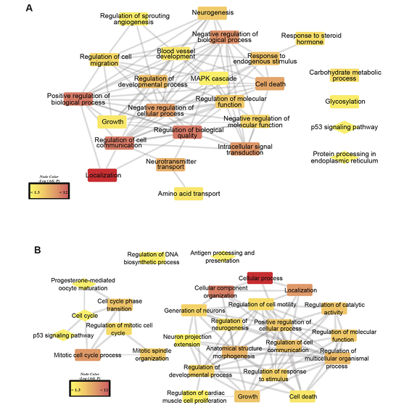

REVIEWER 4
Reviewer 4, Comment 1: The work is highly impressive. However, the introduction does not fully do justice to the strength and significance of the study. I recommend revising this section, as it is currently weaker than the rest of the manuscript. Also, it feels somewhat fragmented. A more cohesive and comprehensive introduction would better contextualize the study.

Our response: Re-write introduction

Reviewer 4, Comment 2: Under the limitations section, the authors should further elaborate on the use of only male mice. Given that sex differences can influence metabolic syndrome susceptibility and neuropathy outcomes, it would be helpful for the authors to address whether female mice may show different metabolic or neurobiological responses. discuss how this may affect the interpretation, and future directions of the work

Our response: Highlight/expand more in limitations, Refer back to previous reviewer. As mentioned…

EDITORIAL OFFICE COMMENTS - FORMATTING CONCERNS: (See the attached document for "All Revised Manuscripts" for guidelines.
Please remove the color font from the main document text.
A Graphical abstract is encouraged but not required. Graphical abstracts are a visual summary of the article. Graphical abstracts are uploaded to the submission website individually, and the file name should be simple and descriptive, e.g., graphical_abstract.tiff.
__________________________________________________
ASSOCIATE EDITOR'S COMMENTS TO AUTHORS:
Diabetes is reconsidering titles in order to reach larger audiences. We suggest a minor title change for your manuscript as "Lifestyle Interventions for Metabolic Syndrome–Associated Peripheral Neuropathy" - broad interest. Alternatively, "Ketogenic Diet and Exercise Improve Peripheral Neuropathy in a Mouse Model of Metabolic Syndrome" - simple/direct tone. Please let us know if either reflects the subject matter of your study or if you would have another suggestion for the title.

